**P/N: YX-WA112-NF**

**6.57 - 9.99 GHz Waveguide Coaxial Adapter Right Angle**

**Descriptions:**

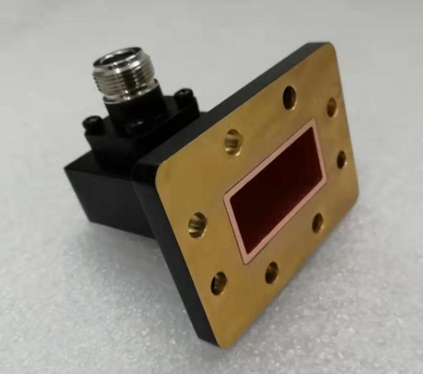

Model YX-WA112-NFis a WR112 Waveguide Coaxial Adapter with N connector,90° Right Angle from 6.57 to 9.99 GHz,the RF port is equipped with N connector which is optional.

**Features:**

**Applications:**

• Low loss,VSWR

• Good matching

• Wideband characteristics

• Microwave communication

• Radar systems

• The field of test and measurement



|  |  |
| --- | --- |
| Electrical & Environmental Specifications | |
| **Frequency Range** | 6.57 - 9.99GHz |
| **Insertion Loss** | ≤0.3dB |
| **VSWR** | ≤1.25 |
| **Operating Temperature** | -55°to +85°C |

|  |  |
| --- | --- |
| Mechanical Specifications | |
| **Flange Type** | UBR84(FBP84) |
| **Coaxial Connector** | N-Female/Male |
| **Configuration** | Right Angle |
| **Material** | Brass/Aluminium |
| **Inside finish** | Nickel plating/Chromate |
| **Outside Finish** | Blue/Grey painting(Optional) |

**Outline Drawing（Unit:mm）:**

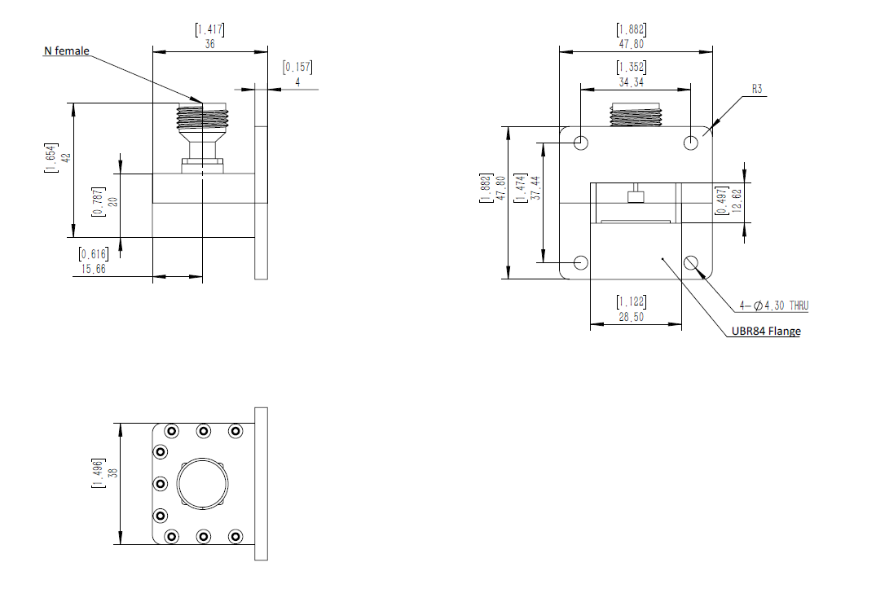

YERSON and its affiliates reserve the right to make changes to the products or information contained herein without prior notice. Please visit www.yersontech.com for additional datasheets and product information.

**Outline Drawing:**

YERSON and its affiliates reserve the right to make changes to the products or information contained herein without prior notice. Please visit www.yersontech.com for additional datasheets and product information.