**P/N: YX-WA15-V1.85F**

**49.8 - 75.5 GHz Waveguide Coaxial Adapter Right Angle**

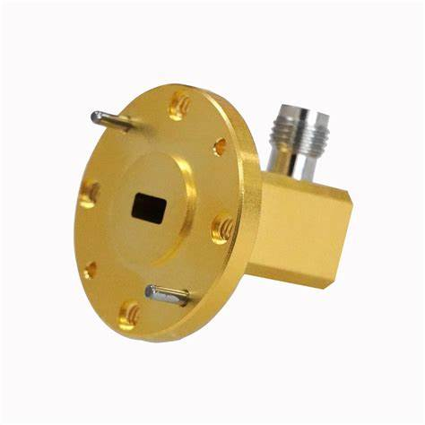

**Descriptions:**

Model YX-WA15-V1.85is a WR12 Waveguide Coaxial Adapter with V1.85 connector,90° Right Angle from 49.8 to 75.5 GHz,the RF port is equipped with V1.85 connector which is optional.

**Features:**

**Applications:**

• Low loss,VSWR

• Good matching

• Wideband characteristics

• Microwave communication

• Radar systems

• The field of test and measurement



|  |  |
| --- | --- |
| Electrical & Environmental Specifications | |
| **Frequency Range** | 49.8-75.5GHz |
| **Insertion Loss** | ≤0.8dB |
| **VSWR** | ≤1.6 |
| **Operating Temperature** | -40°to +70°C |

|  |  |
| --- | --- |
| Mechanical Specifications | |
| **Flange Type** | UG-385/U(FUGP620) |
| **Coaxial Connector** | 1.85mm-Female/Male |
| **Configuration** | Right Angle |
| **Material** | Brass |
| **Inside finish** | Gold plating |
| **Outside Finish** | Gold plating |

**Outline Drawing（Unit:mm）:**

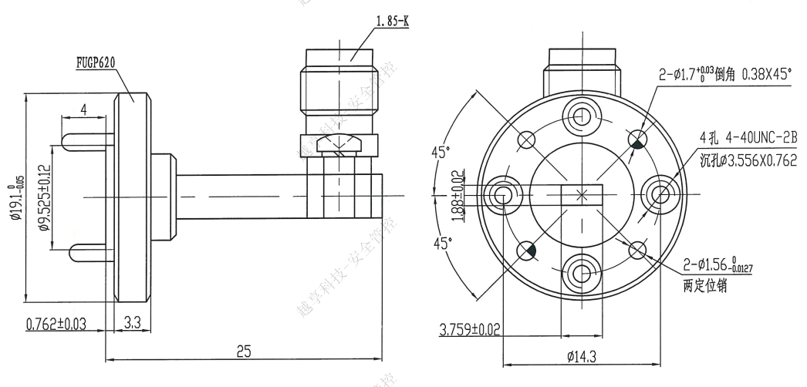

YERSON and its affiliates reserve the right to make changes to the products or information contained herein without prior notice. Please visit www.yersontech.com for additional datasheets and product information.

**Outline Drawing:**

YERSON and its affiliates reserve the right to make changes to the products or information contained herein without prior notice. Please visit www.yersontech.com for additional datasheets and product information.