**P/N: YX-WA42-SMAF**

**18.0 - 26.5 GHz Waveguide Coaxial Adapter Right Angle**

**Descriptions:**

Model YX-WA42-SMAFis a WR42 Waveguide Coaxial Adapter with SMA connector,90° Right Angle from 18.0 to 26.5 GHz,the RF port is equipped with SMA-F connector which is optional.

**Features:**

**Applications:**

• Low loss,VSWR

• Good matching

• Wideband characteristics

• Microwave communication

• Radar systems

• The field of test and measurement



|  |  |
| --- | --- |
| Electrical & Environmental Specifications | |
| **Frequency Range** | 18.0 - 26.5GHz |
| **Insertion Loss** | ≤0.4dB |
| **VSWR** | ≤1.25 |
| **Operating Temperature** | -55°to +85°C |

|  |  |
| --- | --- |
| Mechanical Specifications | |
| **Flange Type** | UBR220(FBP220) |
| **Coaxial Connector** | SMA-Female/Male |
| **Configuration** | Right Angle |
| **Material** | Brass/Aluminium |
| **Inside finish** | Gold plating/Chromate |
| **Outside Finish** | Blue/Grey painting(Optional) |

**Outline Drawing（Unit:mm）:**

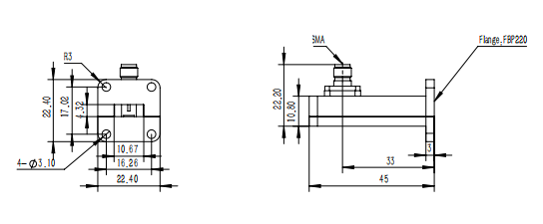

YERSON and its affiliates reserve the right to make changes to the products or information contained herein without prior notice. Please visit www.yersontech.com for additional datasheets and product information.

**Outline Drawing:**

YERSON and its affiliates reserve the right to make changes to the products or information contained herein without prior notice. Please visit www.yersontech.com for additional datasheets and product information.