**P/N: YX-WA62-SMAF**

**11.9 - 18.0 GHz Waveguide Coaxial Adapter Right Angle**

**Descriptions:**

Model YX-WA62-SMAis a WR62 Waveguide Coaxial Adapter with SMA connector,90° Right Angle from 11.9 to 18.0 GHz,the RF port is equipped with SMA connector which is optional.

**Features:**

**Applications:**

• Low loss,VSWR

• Good matching

• Wideband characteristics

• Microwave communication

• Radar systems

• The field of test and measurement



|  |  |
| --- | --- |
| Electrical & Environmental Specifications | |
| **Frequency Range** | 11.9 - 18.0GHz |
| **Insertion Loss** | ≤0.3dB |
| **VSWR** | ≤1.25 |
| **Operating Temperature** | -55°to +85°C |

|  |  |
| --- | --- |
| Mechanical Specifications | |
| **Flange Type** | UBR140(FBP140) |
| **Coaxial Connector** | SMA-Female/Male |
| **Configuration** | Right Angle |
| **Material** | Brass/Aluminium |
| **Inside finish** | Nickel plating/Chromate |
| **Outside Finish** | Blue/Grey painting(Optional) |

**Outline Drawing（Unit:mm）:**

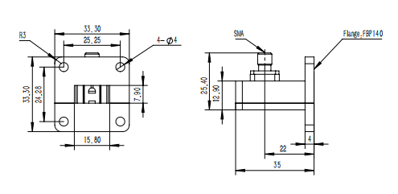

YERSON and its affiliates reserve the right to make changes to the products or information contained herein without prior notice. Please visit www.yersontech.com for additional datasheets and product information.

**Outline Drawing:**

YERSON and its affiliates reserve the right to make changes to the products or information contained herein without prior notice. Please visit www.yersontech.com for additional datasheets and product information.