**P/N: YX-WTL229**

**3.3-4.9GHz WR229 Waveguide Terminal Load,10W cw**

**Descriptions:**

Model YX-WTL229 is a WR229 Waveguide Terminal Load,which operating at 3.3 to 4.9 GHz and bearing power 10W cw,the RF port is equipped with waveguide flange which is optional.

**Applications:**

**Features:**

• Low standing wave ratio

• Small reflection

• Stable performance

• Electronic circuits

• Motor drive systems

• Communication systems

• Power systems



|  |  |
| --- | --- |
| Electrical & Environmental Specifications | |
| **Frequency Range** | 3.3 - 4.9GHz |
| **VSWR** | ≤1.05 |
| **Average Power** | 10 W |
| **Operating Temperature** | -55°to +85°C |

|  |  |
| --- | --- |
| Mechanical Specifications | |
| **Flange Type** | FDP26 |
| **Material** | Brass/Aluminium |
| **Inside finish** | Nickel plating/Chromate |
| **Outside Finish** | Blue/Grey painting(Optional) |

**Outline Drawing（Unit:mm）:**

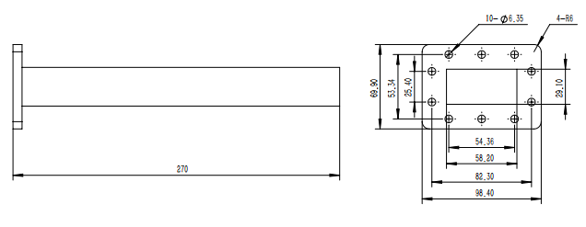

YERSON and its affiliates reserve the right to make changes to the products or information contained herein without prior notice. Please visit www.yersontech.com for additional datasheets and product information.

**Outline Drawing:**

YERSON and its affiliates reserve the right to make changes to the products or information contained herein without prior notice. Please visit www.yersontech.com for additional datasheets and product information.