**P/N: YX-WA10-1.0F**

**73.8-110 GHz Waveguide Coaxial Adapter Right Angle**

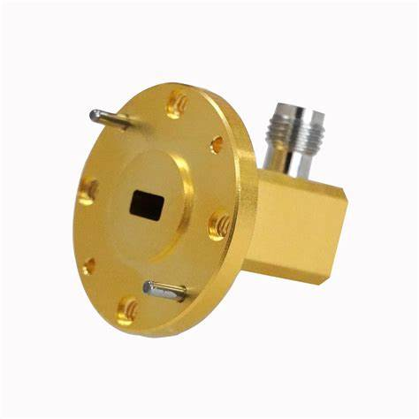

**Descriptions:**

Model YX-WA10-1.0Fis a WR10 Waveguide Coaxial Adapter with 1.0 connector,90° Right Angle from 73.8 to 110 GHz,the RF port is equipped with 1.0 connector which is optional.

**Features:**

**Applications:**

• Low loss,VSWR

• Good matching

• Wideband characteristics

• Microwave communication

• Radar systems

• The field of test and measurement



|  |  |
| --- | --- |
| Electrical & Environmental Specifications | |
| **Frequency Range** | 73.8-110GHz |
| **Insertion Loss** | ≤1.0dB |
| **VSWR** | ≤1.55 |
| **Operating Temperature** | -40°to +70°C |

|  |  |
| --- | --- |
| Mechanical Specifications | |
| **Flange Type** | UG-387/U-M（FUGP900) |
| **Coaxial Connector** | 1.0mm-Female/Male |
| **Configuration** | Right Angle |
| **Material** | Brass |
| **Inside finish** | Gold plating |
| **Outside Finish** | Gold plating |

**Outline Drawing（Unit:mm）:**

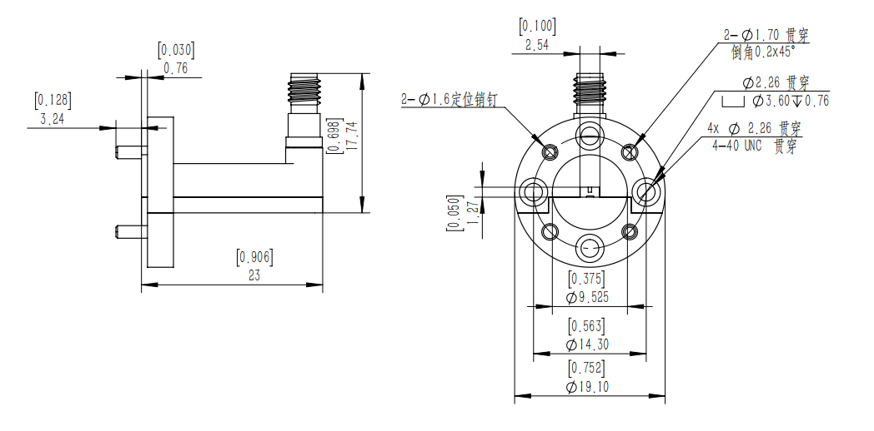

YERSON and its affiliates reserve the right to make changes to the products or information contained herein without prior notice. Please visit www.yersontech.com for additional datasheets and product information.

**Outline Drawing:**

YERSON and its affiliates reserve the right to make changes to the products or information contained herein without prior notice. Please visit www.yersontech.com for additional datasheets and product information.