SPDT/2.92/40GHz/Latching Type

**Coaxial Switch**

Features:

• DC to 40GHz

• Higher reliability and longer lifespan

• Wide frequency range

• Low insertion loss, Low standing wave, high isolation

Typical Applications:

• 5G communication testing, automated testing equipment

• Communication and Navigation System

• Military Aerospace Communication System

• Precision measuring equipment, radar transmitter RF signal control

Electrical Specifications:

|  |  |  |  |  |  |
| --- | --- | --- | --- | --- | --- |
| Parameter | Typical | | | | |
| Frequency Range | DC-6GHz | 6-12.4GHz | 12.4-18GHz | 18-26.5GHz | 26.5-40GHz |
| VSWR(Max) | 1.30 | 1.40 | 1.50 | 1.60 | 1.90 |
| Insertion Loss(Max) | 0.30dB | 0.40dB | 0.50dB | 0.80dB | 0.90dB |
| Isolation(Min) | 70dB | 65dB | 60dB | 55dB | 50dB |
| Power handing(W) | 30W | 20W | 15W | 10W | 5W |

dB

Technical Specifications:

|  |  |
| --- | --- |
| Parameter | Typical |
| RF Impedance | 50Ω |
| Control voltage/current | DC12V/200mA |
| DC24V/100mA(Option:5V,15V,28V) |
| Switching time | <15ms |
| Operating life | >1000000cycles |
| Operating Temperature | -25℃ to+65℃ |
| RF Interface | K(2.92mm) female |

SPDT/2.92/40GHz/Latching Type

**Coaxial Switch**

**Schematics:**

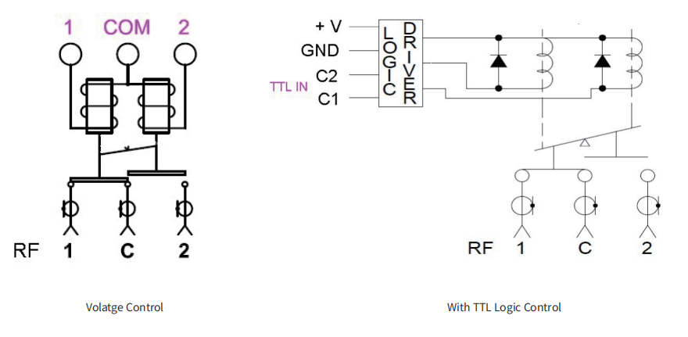

**Outline Drawing:**

All Dimensions in mm

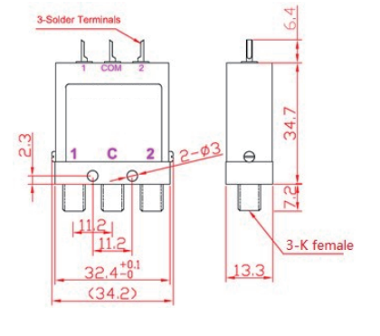

lQLPJxYTcqtAvCNCO7BqTtQCsYIu-Ab1KAhm-5kA_59_66

YERSON and its affiliates reserve the right to make changes to the products or information contained herein without prior notice. Please visit www.yersontech.com for additional data-sheets and product information.

**Outline Drawing:**